ALPHABET INC.
NASDAQ: GOOGL | CLASS A

Recommendation | 12-Month Target | 3/12/26 Close | Price Upside | Total Return
BUY | $320 | $303.55 | 5.4% | 5.7%

Investment view: Alphabet remains the best-positioned scaled digital platform to convert AI adoption into revenue across Search, Cloud, subscriptions, and enterprise software. The 2026 infrastructure build creates a near-term free-cash-flow trough, but the base case assumes durable double-digit revenue growth, expanding Cloud profitability, and normalization of capital intensity beginning in 2027.

Investment Thesis
AI strengthens rather than replaces the core Search franchise. Management reported record Search usage, 17% fourth-quarter Search growth, and no observed cannibalization from Gemini. AI Overviews and AI Mode expand query complexity and create additional commercial inventory.
Google Cloud has reached a structurally stronger growth and margin phase. Cloud revenue grew 36% in 2025 and 48% in the fourth quarter, while year-end backlog reached $240 billion. AI customers adopt more products, supporting revenue depth and operating leverage.
Alphabet can absorb the AI investment cycle from a position of financial strength. The company generated $164.7 billion of 2025 operating cash flow and held $126.8 billion of cash and marketable securities. Even after a major 2026 capex step-up, the balance sheet supports sustained investment and shareholder returns.

Key Risks
The principal risks are: (1) AI infrastructure returns arriving more slowly than expected, (2) regulatory remedies that impair Search distribution economics, (3) generative AI competition reducing query share or ad monetization, and (4) legal, privacy, and antitrust costs.
Source: Alphabet 2025 Form 10-K; Alphabet Q4 2025 earnings release and conference call; GOOGL historical close from Yahoo Finance. Financial data available on or before March 12, 2026.

1. Company and Business Overview
Alphabet is a global technology holding company whose principal operating businesses are organized into Google Services, Google Cloud, and Other Bets. Google Services includes Search, YouTube, Android, Chrome, Maps, Google Play, devices, and consumer subscriptions. Google Cloud includes Google Cloud Platform, Workspace, cybersecurity, data and analytics, and enterprise AI products. Other Bets includes earlier-stage businesses such as Waymo.
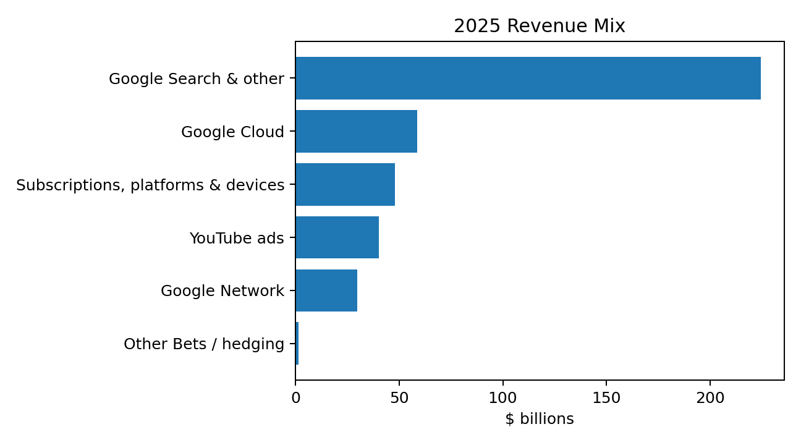
Source: Alphabet 2025 Form 10-K. Revenue figures in $ billions.

Business model and economic engine
Business | 2025 Revenue | Primary Economics | Strategic Role
Google Search & other | $224.5B | Auction-based advertising; high intent and strong incremental margins | Core cash engine and distribution layer for AI
YouTube ads | $40.4B | Brand and direct-response advertising | Video attention, creator ecosystem, connected TV
Google Network | $29.8B | Ad placement on third-party properties | Extends advertiser reach; structurally lower-growth
Subscriptions, platforms & devices | $48.0B | YouTube/Google One subscriptions, Play, devices | Diversifies revenue and monetizes consumer ecosystem
Google Cloud | $58.7B | Consumption and subscriptions | Fastest-growing scaled segment and AI monetization platform
Other Bets | $1.5B | Early-stage products and services | Long-duration option value, led by Waymo

Competitive positioning
Alphabet's advantage is not a single model. It is the integration of global consumer distribution, proprietary data, custom TPUs, leading foundation models, enterprise sales, and an advertising system capable of monetizing commercial intent. This full-stack position reduces reliance on external compute vendors and gives Alphabet multiple paths to monetize each AI improvement.

2. Industry and Competitive Positioning

Digital advertising
Search advertising remains attractive because advertiser spending is tied closely to measurable consumer intent. Alphabet's 2025 Search growth reflected higher query activity, advertiser spending, and improvements in ad formats and delivery. The key debate is whether generative AI shifts discovery away from traditional search. The base case instead assumes that conversational interfaces increase the number, length, and complexity of queries while Google's ad stack adapts to the new formats.

Cloud and enterprise AI
Enterprise cloud demand is increasingly driven by training, inference, data modernization, cybersecurity, and AI agents. Google Cloud benefits from proprietary TPUs, Gemini models, Vertex AI, Workspace distribution, and partnerships with leading AI developers. Nearly 75% of Cloud customers had used Google's vertically optimized AI offerings by the end of 2025, and generative-AI product revenue grew nearly 400% year over year in the fourth quarter.
Dimension | Alphabet Strength | Primary Competitive Risk
Consumer distribution | Search, Android, Chrome, YouTube, Maps and Gmail reach billions of users | User behavior may fragment across standalone AI assistants
AI infrastructure | TPUs, NVIDIA access, global data centers and network | Capital requirements and rapid hardware obsolescence
Models and products | Gemini integrated across consumer and enterprise surfaces | Model leadership may rotate quickly
Advertising | Largest intent-driven ad ecosystem and automated bidding tools | Regulatory remedies and changes to default distribution
Enterprise | Cloud, Workspace, cybersecurity, data and AI stack | AWS and Microsoft retain larger enterprise footprints
Capital resources | Large cash balance and operating cash flow | Returns could lag the pace of investment

Why the market may be underestimating Alphabet
The market's focus on 2026 capital expenditures is justified, but it can obscure the simultaneous acceleration in Search and Cloud. The BUY case does not require immediate free-cash-flow growth. It requires evidence that elevated infrastructure spending converts into durable revenue, Cloud margins, and new monetization surfaces over the following several years.

3. Historical Financial Analysis
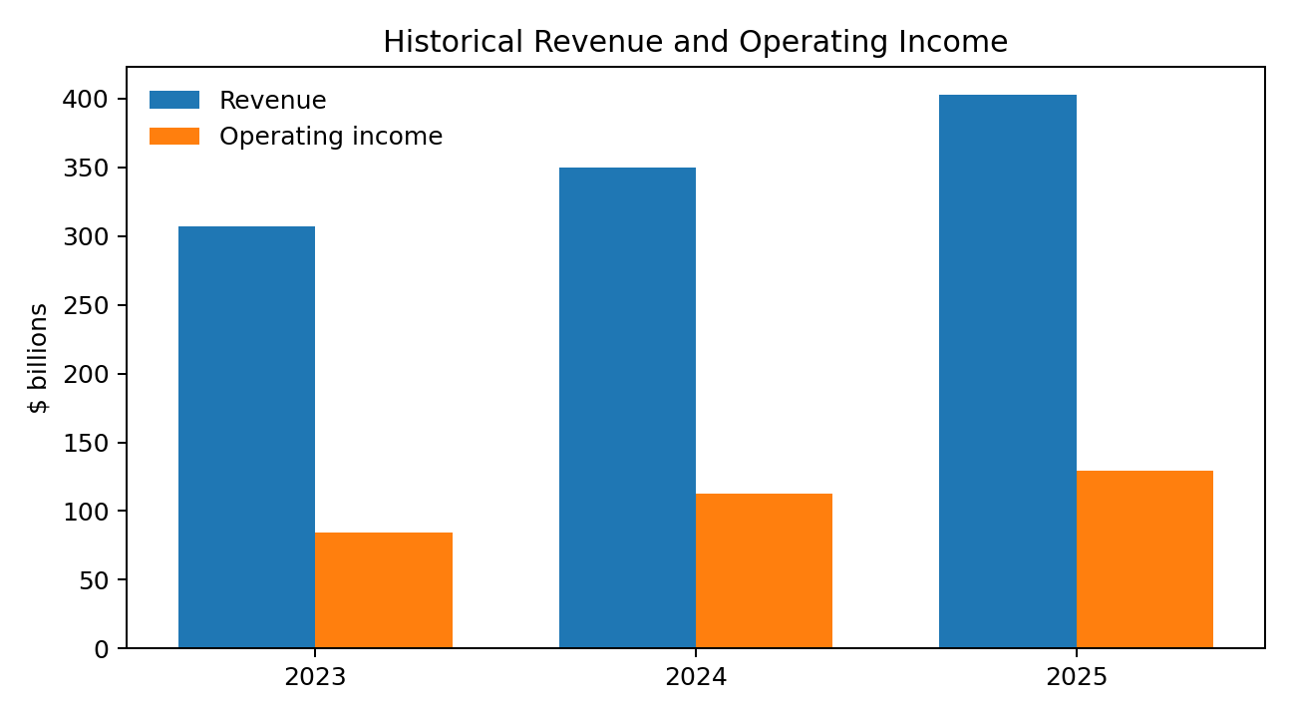
Source: Alphabet Forms 10-K. $ billions.
Year | Revenue | Op. Margin | Net Income | Operating CF | Capex | FCF
2023 | $307.4 | 27.4% | $73.8 | $101.7 | $32.3 | $69.5
2024 | $350.0 | 32.1% | $100.1 | $125.3 | $52.5 | $72.8
2025 | $402.8 | 32.0% | $132.2 | $164.7 | $91.4 | $73.3

Key historical observations
- Revenue increased 15% in 2025 to $402.8 billion, with Google Services up 12% and Google Cloud up 36%.
- Operating income increased 15% to $129.0 billion. Reported operating margin remained approximately 32% despite higher AI research, infrastructure depreciation, and legal costs.
- Reported net income increased 32% to $132.2 billion, but $24.1 billion of equity-security gains made reported earnings less representative of recurring operating performance.
- Operating cash flow increased to $164.7 billion. Free cash flow remained near $73.3 billion because capital expenditures rose to $91.4 billion.
- Cloud operating income more than doubled to $13.9 billion, implying a 23.7% segment operating margin versus 14.1% in 2024.

4. Segment Analysis
Segment / Revenue Type | 2024 | 2025 | Growth
Google Search & other | $198.1B | $224.5B | 13.4%
YouTube ads | $36.1B | $40.4B | 11.7%
Google Network | $30.4B | $29.8B | (1.9%)
Subscriptions, platforms & devices | $40.3B | $48.0B | 19.1%
Google Cloud | $43.2B | $58.7B | 35.8%
Other Bets | $1.6B | $1.5B | (6.7%)

Google Services
Google Services remains the profit center, generating $139.4 billion of 2025 operating income. Search benefited from 6% paid-click growth and 7% cost-per-click growth. YouTube advertising grew 12%, while subscriptions benefited from YouTube services and Google One. The Network business declined and is modeled as a low-growth or contracting asset.

Google Cloud
Cloud is the most important incremental valuation driver. Revenue reached $58.7 billion in 2025, operating income reached $13.9 billion, and fourth-quarter revenue grew 48%. The $240 billion backlog, larger customer commitments, and high AI product adoption provide visibility, although capacity constraints and infrastructure costs remain material.

Other Bets
Other Bets generated a $7.5 billion operating loss in 2025, including a valuation-based compensation charge related to Waymo. The valuation gives limited explicit credit to Other Bets; this is conservative because Waymo and other businesses may possess meaningful standalone option value.

5. AI Strategy and Monetization
Alphabet's AI thesis is built around four layers: infrastructure, models, distribution, and monetization. The company owns custom TPUs, operates global data centers, develops Gemini models, and distributes AI through Search, YouTube, Workspace, Cloud, Android, Chrome, and the Gemini app.
Indicator reported Feb. 4, 2026 | Reported Level | Investment Significance
Gemini app monthly active users | 750M+ | Scaled direct consumer distribution
Consumer paid subscriptions | 325M+ | Existing subscription monetization base
Gemini Enterprise paid seats | 8M+ | Early enterprise product-market fit
Cloud backlog | $240B | Demand visibility and capacity requirement
Cloud quarterly growth | 48% | AI-driven acceleration
Gemini serving unit-cost reduction | 78% during 2025 | Improving model economics
Direct API token processing | 10B+ tokens per minute | Developer and enterprise adoption
2026 expected capex | $175B-$185B | Near-term FCF pressure; long-term capacity build

Monetization pathways
Search advertising: AI Overviews and AI Mode can expand query frequency and enable monetization of longer, more complex commercial questions.
Cloud infrastructure and platforms: Training, inference, data, cybersecurity, Vertex AI, and Gemini APIs generate consumption revenue.
Enterprise agents: Gemini Enterprise and Workspace features monetize through seats and usage.
Consumer subscriptions: Google One and YouTube provide an established path for premium AI features.
Commerce and transactions: Agentic shopping tools may allow Alphabet to participate more directly in discovery-to-transaction flows.

6. Financial Forecast
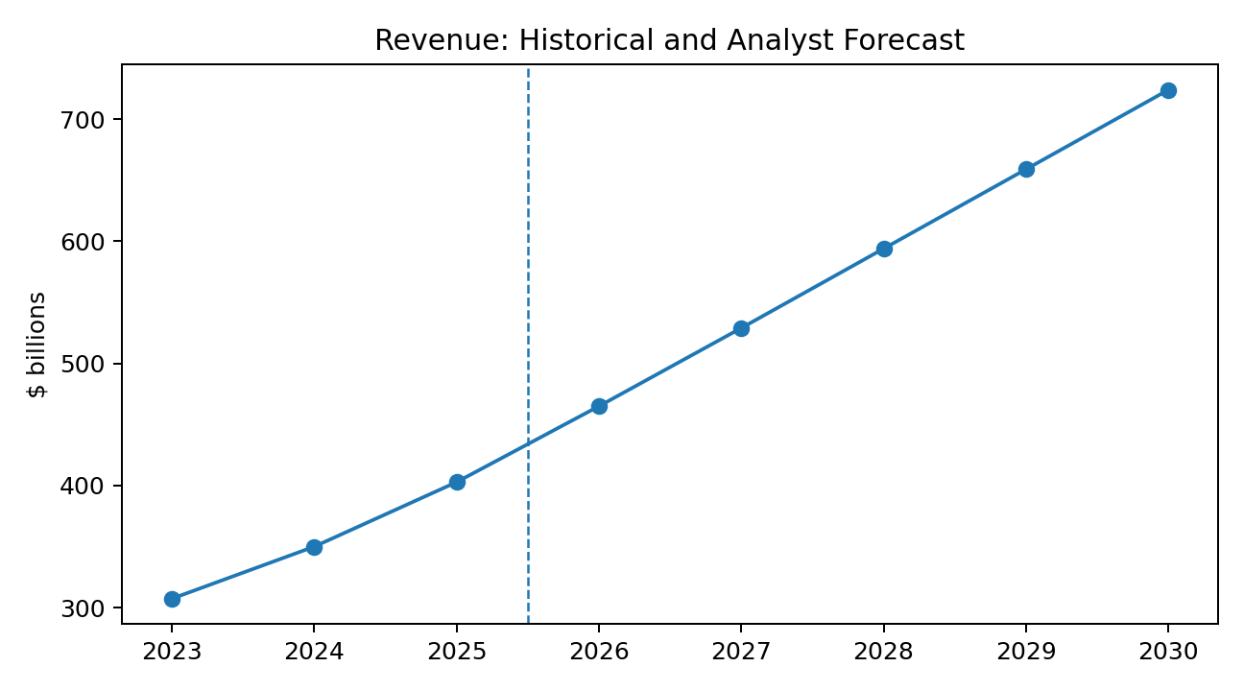
Source: 2023-2025 actual; 2026-2030 independent analyst estimates.
Year | Revenue | Growth | Op. Margin | Op. Income | Norm. EPS | Capex | FCF
2026 | $465B | 15.4% | 30.0% | $139.5B | $11.60 | $180B | $48B
2027 | $529B | 13.8% | 31.0% | $164.0B | $13.30 | $170B | $82B
2028 | $594B | 12.3% | 32.0% | $190.1B | $15.20 | $155B | $120B
2029 | $659B | 10.9% | 33.0% | $217.5B | $17.30 | $145B | $157B
2030 | $724B | 9.9% | 33.5% | $242.5B | $19.40 | $140B | $194B

Forecast assumptions
- Search growth moderates from the strong 2025 exit rate but remains supported by AI-driven query growth, ad automation, and commercial intent.
- Cloud remains the fastest-growing major business, with growth decelerating gradually as its revenue base expands and backlog converts.
- Subscriptions, platforms, and devices continue to grow at a double-digit rate; Network revenue remains pressured.
- 2026 capex is modeled at $180 billion, the midpoint of management's range. Capex declines gradually as a percentage of revenue after the initial capacity build.
- Operating margin dips in 2026 due to depreciation, energy, and infrastructure costs, then recovers as Cloud mix and utilization improve.
- Normalized EPS excludes unusually large unrealized investment gains and is intended to represent recurring earnings power.

7. Cash Flow and Capital Allocation
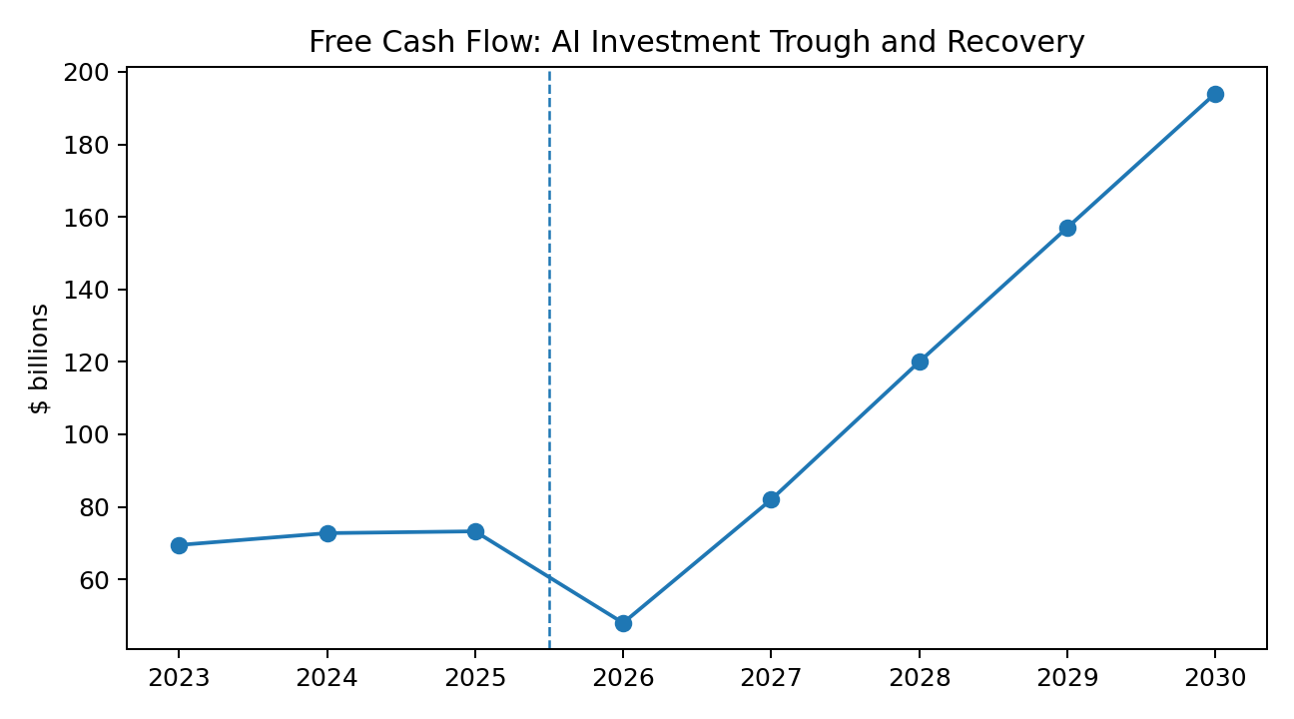
Source: 2023-2025 actual; 2026-2030 independent analyst estimates.
The forecast intentionally shows a free-cash-flow trough in 2026. A bullish valuation should not treat AI infrastructure as costless. The investment case instead assumes that capex creates durable capacity and that free cash flow recovers as revenue grows, utilization rises, and the construction cycle matures.
Capital Allocation Item | 2025 Actual / Status | Assessment
Operating cash flow | $164.7B | Strong internally funded investment capacity
Capital expenditures | $91.4B | Rapidly rising AI and data-center investment
Share repurchases | $45.4B | Supports per-share growth, but below 2024 pace
Dividend declared | $0.83 per share | Modest yield; signals recurring capital return
Cash and marketable securities | $126.8B | Substantial liquidity
Long-term debt | $46.5B | Manageable relative to cash flow and asset base

Capital-allocation view
The preferred sequence is: fund high-return AI capacity, preserve balance-sheet flexibility, complete strategically coherent acquisitions, and return residual cash through repurchases and dividends. The largest risk is not the absolute capex figure; it is a sustained gap between infrastructure spending and monetizable demand.

8. Discounted Cash Flow Valuation
The DCF is presented as a conservative anchor because near-term cash flow is unusually depressed by infrastructure investment. The model uses explicit 2026-2030 free cash flow, a mid-cycle normalization adjustment beyond 2030, and a terminal framework consistent with Alphabet's scale and long-duration competitive position.
DCF Assumption | Base Case
Valuation date | March 12, 2026
Explicit forecast period | 2026-2030
2026 free cash flow | $48B
2030 free cash flow | $194B
WACC | 7.8%
Terminal growth | 3.5%
Net cash / investments adjustment | Included
Diluted share base | Approximately 12.1B total classes
Implied value per share | $305

Terminal Growth / WACC | 7.2% | 7.5% | 7.8% | 8.1% | 8.4%
2.8% | $293 | $282 | $271 | $260 | $249
3.1% | $307 | $296 | $285 | $275 | $264
3.5% | $327 | $316 | $305 | $294 | $283
3.8% | $342 | $331 | $320 | $309 | $298
4.1% | $356 | $345 | $334 | $323 | $312

Interpretation: the DCF alone does not create the BUY rating. It provides downside discipline. The blended target incorporates the higher earnings-based value implied by recovering free cash flow and Cloud mix.

9. Comparable-Company Valuation
Public-company comparables are used as a reasonableness check rather than a mechanical answer. Alphabet combines advertising, cloud, software, devices, and venture-like assets, so no single peer is directly comparable.
Peer | Relevant Comparison | Why It Matters
Microsoft | Cloud, enterprise software, AI distribution | Premium multiple for recurring enterprise revenue and AI monetization
Amazon | Cloud infrastructure and scaled digital platform | Cloud growth and infrastructure intensity
Meta Platforms | Digital advertising and consumer engagement | Advertising growth, margins, and AI recommendation systems
Apple | Consumer ecosystem and distribution | Platform control, devices, services, and capital returns
Oracle | Enterprise cloud and contracted backlog | Backlog conversion and infrastructure economics

Forward earnings framework
Metric | Base Assumption
2027 normalized EPS | $13.30
Selected forward P/E | 24.7x
Implied equity value | $328 per share
Rationale | Premium to slower-growth platforms; discount to the strongest recurring-software franchises

EV/EBITDA / peer framework
A blended peer framework produces an implied value of approximately $342 per share. This higher result reflects the value of Cloud growth, Search margins, the net cash and investment portfolio, and limited credit for Other Bets. A 20% weight is used because differences in business mix and capex accounting reduce precision.

10. Valuation Conclusion and Price Target
Method | Implied Price | Weight | Contribution
DCF | $305 | 45% | $137.2
Forward P/E | $328 | 35% | $114.8
EV/EBITDA / peer framework | $342 | 20% | $68.4
Blended indicated value | $320 | 100% | $320.4
Published 12-month target | $320 | - | Rounded / conservatism

At the March 12, 2026 closing price of $303.55, the $320 target implies 5.4% price appreciation and approximately 5.7% total return including the indicated annual dividend. This is a modest nominal upside for a BUY rating; the rating reflects the quality of the franchise, balance-sheet resilience, and favorable base-to-bull asymmetry rather than a deeply discounted entry point.

Why the target is not higher
The target incorporates a meaningful valuation discount for the 2026 free-cash-flow trough, uncertain returns on AI infrastructure, ongoing antitrust remedies, and the possibility that reported investment gains overstate recurring earnings. The model therefore avoids capitalizing the bull case fully.

11. Bull, Base, and Bear Scenarios
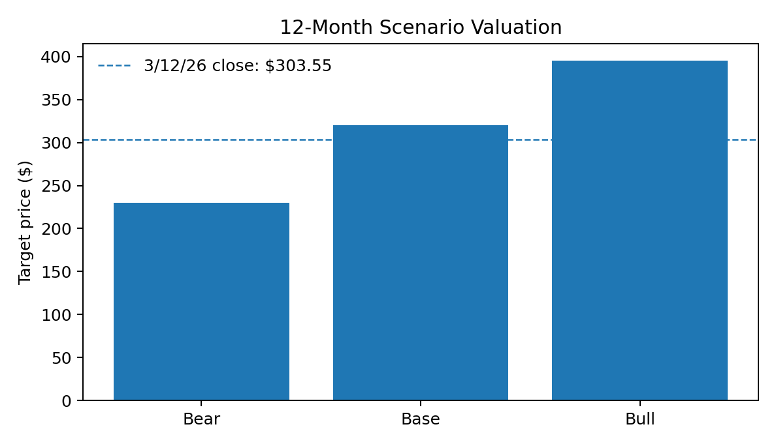
Scenario | Probability | Target | Key Assumptions
Bear | 25% | $230 | Search growth falls to mid-single digits; AI capex remains elevated; Cloud growth slows; regulatory remedies pressure distribution and margins.
Base | 55% | $320 | Double-digit consolidated growth moderates gradually; Cloud backlog converts; 2026 is the FCF trough; margins recover after 2026.
Bull | 20% | $395 | Search AI monetization accelerates; Cloud sustains 30%+ growth longer; capex efficiency improves; Other Bets receives greater market credit.

Probability-weighted scenario value
The probability-weighted scenario value is approximately $312 per share. The published $320 target is slightly below that result and represents a conservative rounding of the base-case framework.

12. Catalysts
Catalyst | Expected Timing | Potential Impact
Cloud backlog conversion and sustained 40%+ near-term growth | 2026 quarterly results | Supports higher Cloud revenue and margin estimates
Evidence that AI Mode monetizes commercial queries | 2026 product and earnings updates | Reduces Search cannibalization concerns
Gemini Enterprise seat and usage growth | 2026 | Validates enterprise AI revenue opportunity
Improved capex efficiency or lower-than-feared 2027 capex | Late 2026 / early 2027 | Raises free-cash-flow estimates and valuation
Wiz and Intersect integration milestones | 2026-2027 | Strengthens security and data-center capacity
Waymo commercial expansion or external valuation event | 2026-2027 | Unlocks option value not fully reflected in base case
Continued repurchases during volatility | Ongoing | Supports per-share value

13. Investment Risks
AI capex returns: Management expected $175-$185 billion of 2026 capex. If demand, utilization, pricing, or hardware life fails to support adequate returns, free cash flow and valuation could remain depressed.
Search disruption: Standalone assistants and answer engines could reduce traditional query share, commercial click-through, or advertiser economics.
Regulatory and antitrust remedies: Distribution agreements, ad technology, app-store practices, privacy requirements, and European fines could raise costs or weaken competitive advantages.
Cloud competition: AWS, Microsoft, Oracle, and specialized AI infrastructure providers may pressure price, capacity access, and customer commitments.
Model and product execution: AI model leadership is not permanent. Safety failures, hallucinations, product delays, or weak developer adoption could damage the thesis.
Legal and accounting volatility: Alphabet had $15.6 billion of accrued short-term legal and regulatory fines and settlements at year-end 2025. Investment gains also introduce earnings volatility.
Other Bets losses: Waymo and other businesses may require substantial funding without producing near-term earnings.

Thesis invalidation indicators
- Two or more quarters of Search deceleration not explained by macro conditions.
- Cloud backlog growth stalls while capex remains near peak levels.
- 2027 capex fails to moderate and free cash flow does not begin recovering.
- Material evidence that AI interfaces cannibalize commercial Search usage.
- Regulatory remedies materially reduce default distribution or ad-tech economics.

14. Governance, ESG, and Capital Allocation
Alphabet's dual-class structure concentrates voting control with founders and insiders, limiting the influence of Class A shareholders. This structure supports long-term investment but reduces external governance accountability. The analysis applies a modest governance discount through conservative valuation weights rather than a separate numerical deduction.
Topic | Assessment
Board and voting structure | Dual-class control limits minority shareholder influence.
Executive incentives | Long-term equity incentives can align management with value creation, though valuation-based compensation may add expense volatility.
Data privacy and content | Core products face persistent privacy, safety, competition, and content-governance scrutiny.
Environmental footprint | Data-center energy and water use rise with AI workloads; efficiency and clean-energy procurement are strategically important.
Human capital | AI talent competition raises compensation costs and execution risk.
Capital returns | Repurchases and dividends provide recurring shareholder returns after growth investment.

15. Appendix: Source Notes and Disclosures

Primary public sources
- Alphabet Inc., Annual Report on Form 10-K for the year ended December 31, 2025, filed February 4, 2026.
- Alphabet Inc., Fourth Quarter and Fiscal Year 2025 earnings release, dated February 4, 2026.
- Alphabet Inc., Q4 2025 earnings conference call transcript, February 4, 2026.
- Yahoo Finance, GOOGL historical data for March 12, 2026 (open $306.82; high $308.94; low $301.03; close $303.55; adjusted close $303.37; volume 24.9 million).
- All forecasts, target prices, scenario probabilities, valuation multiples, and recommendations are independent analyst estimates prepared for this project.

Date-control statement
This report is intentionally written as of March 12, 2026. It excludes Alphabet financial results, guidance, market prices, corporate actions, and other information first released after that date. References to later outcomes are not used in the thesis or valuation.

Important disclosure
This document is an educational portfolio project and is not investment advice, an offer to buy or sell securities, or research issued by a registered broker-dealer or investment adviser. The author may not have access to all information available to professional analysts. Forecasts are inherently uncertain, and actual results may differ materially.

Website project summary
Equity Research: Alphabet Inc. (GOOGL) - BUY, $320 Target. Developed a multi-year financial forecast and valued Alphabet using discounted cash flow, forward earnings, and comparable-company frameworks. The analysis evaluates Search and Cloud growth, AI monetization, a 2026 infrastructure-investment cycle, scenario outcomes, catalysts, and key regulatory and execution risks.

